**Performance Testing using K8**

1. Install kubectl (brew install kubectl) . Validate the install with the command “kubectl version –client”
2. Install minikube (brew install minikube)
3. Start minikube cluster by using “minikube start” command

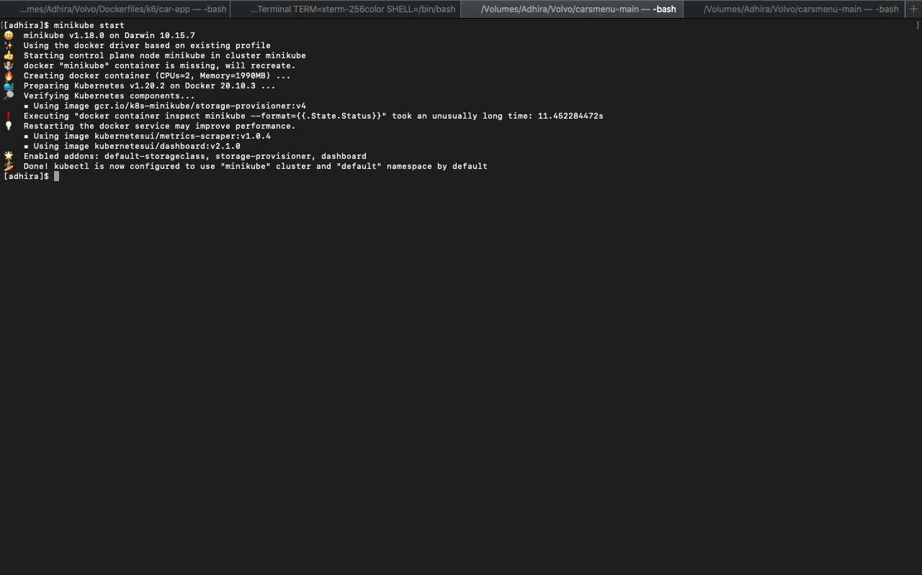

1. Run the command “minikube dashboard” to make sure the Kubernetes cluster is up and running

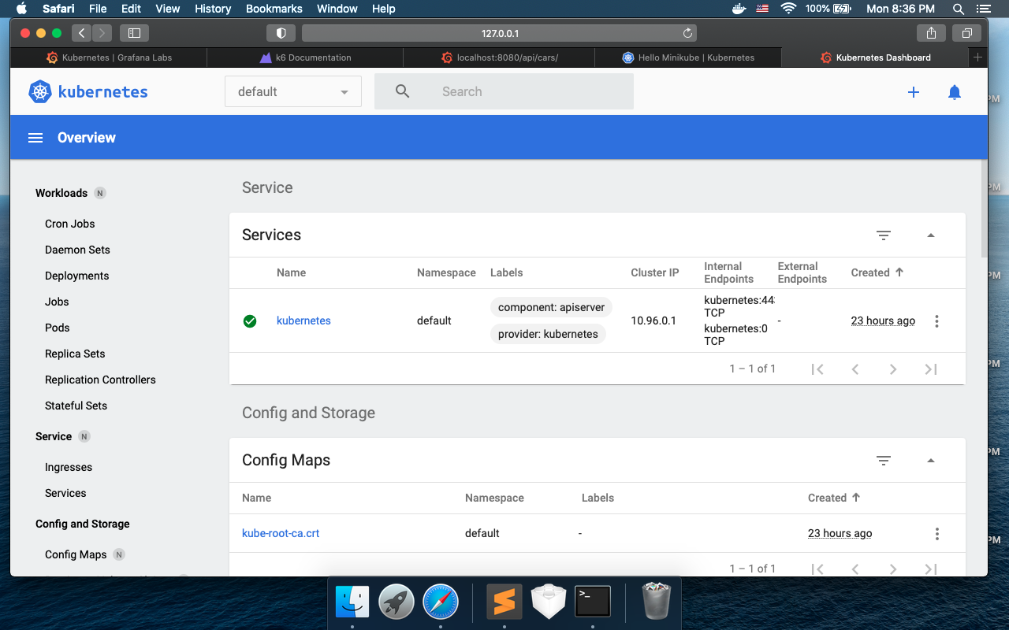

1. Navigate to the folder where you created YAML files for pods and services

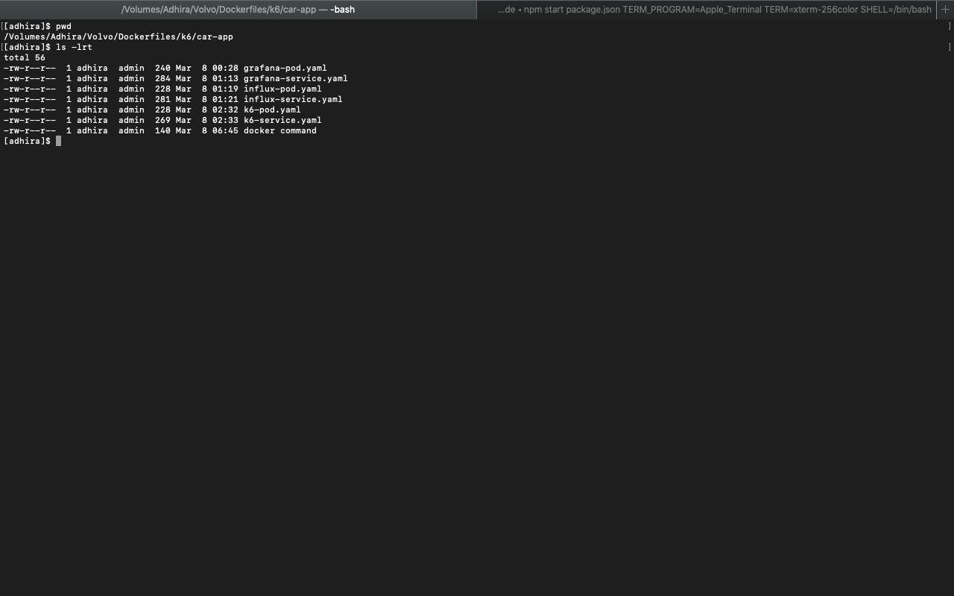

1. Create the pods and services in K8 cluster by running the command “kubectl create -f <pod Yaml file>” and “kubectl create -f <service Yaml file>”

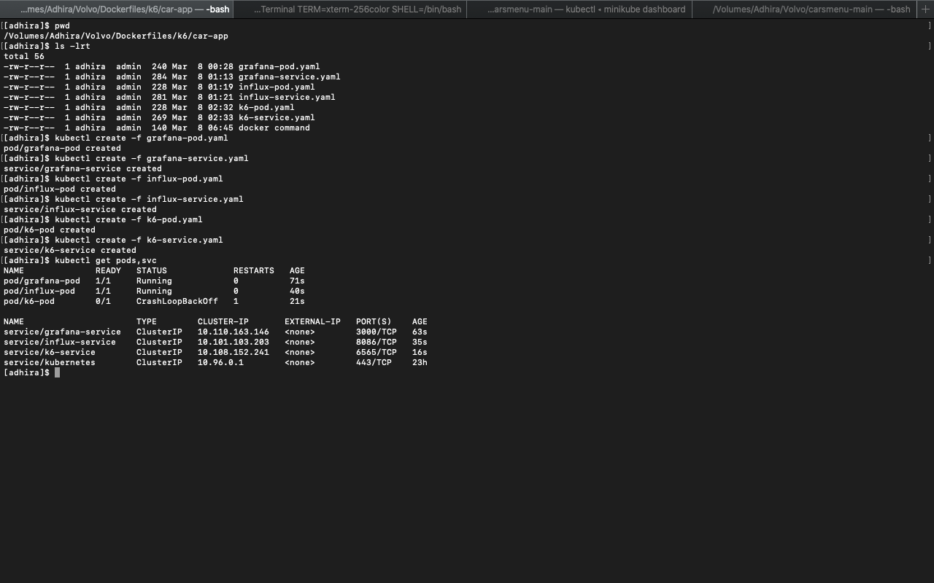

1. Ensure all the pods and services are running in K8 cluster (use kubectl get pods, svc command). Also, view them in K8 dashboard as well.



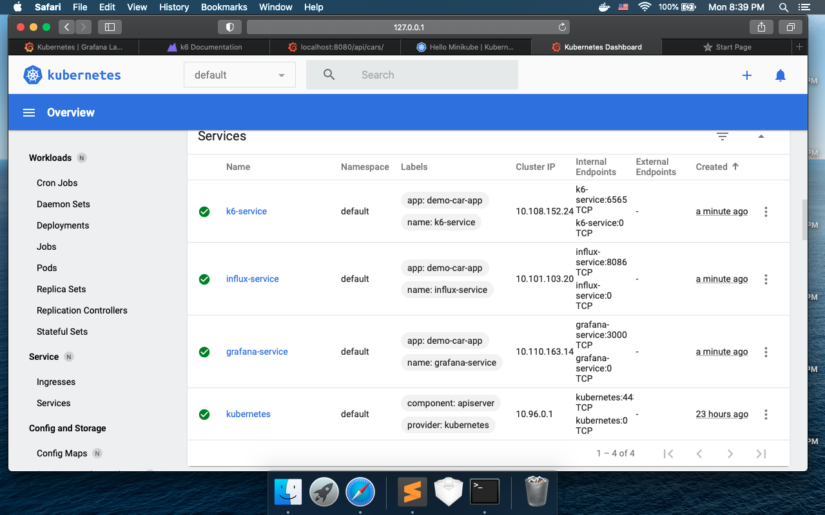

1. Get the URL for Grafana service from K8 cluster. Use the command “minikube service Grafana-service –url”. Once the URL is displayed in the terminal, copy it and hit it in the browser. You see the Grafana login screen.

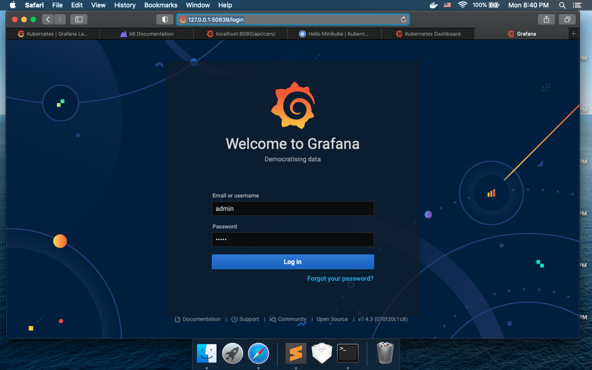

I am unable to run the k6 service successfully in K8 cluster. This is where I struck and unable to proceed. I am still working k6-service.yaml file.